Team Parent Guidelines

Congratulations to your student athlete on being selected as a Captain and thank you for being a team parent at NCHS. Our sports teams would not function as smoothly as they do without you. We have put together some general guidelines to assist you in the process and answer some of the most frequently asked questions. Each team does things slightly differently so some of these responsibilities may not apply to you.

Role of Team Parent:
- Meet with Jay Egan as soon as your child has been assigned as a Captain
- Support the captains and coach with needs/issues as they may arise
- Communicate information to the team via League Athletics email
- Develop a budget and collect team dues
- Set up team dinner schedule
- Identify “Team Moms” for JV and Freshman/Thirds teams where needed
- Communicate preseason information to those interested in the sport
- Communicate important information at coaches meeting at the start of the season
- Coordinate with captains on possible additional apparel being ordered.
- Pick a date and secure a location for the post-season banquet
- Organize/oversee team jobs (SEE BELOW)
Picture day photos
Game photos
Team buttons and roster cards
Senior night
Bus snacks (if necessary)
Team dinners
Gifts (captains, team, seniors, coaches)
Senior posters
Team slide show
Game videos
Tweeting
Publicity
Posting to team website (not the NCHS website)
Copy nchsathletics@ncps-k12.org on ALL communications that go out to the team

Budget
It is the Captains’ Parent responsibility to develop a budget, have it approved by the coach and Jay Egan and collect dues. Ideally, you will receive a copy of the prior year’s budget and work off of that. You should also email Tyler Clay (tyler.clay@ncps-k12.org), the manager of the Student Activity Fund, for a copy of the prior year’s Statement of Activity. This will show all income and disbursements. Her office is in the front office of the High School.

When developing a budget, it is important to remember that all income is only from dues. No other fundraisers are allowed, except with specific approval of the Athletic Director. Dues cannot be increased from year to year without permission of the Athletic Director. If you as a team hire someone, for example a student to take photographs, those wages will need to be paid by central office. Tyler Clay will provide you with instructions on how to get that student paid.

Team Finances
- Develop and manage team budget. This budget will be approved by the Athletic Director and all expenditures will be in accordance with this approved budget
- Only the team parent will submit expense reimbursement requests.
- Only expenditures that directly benefit students can be paid for through the student activity account.
- Funds collected for coaches/other adult gifts cannot be deposited into the school student activity account. The team parent must maintain custody of these funds. Maximum allowable gift is $150 per person.
- Fundraising for charitable organizations must be segregated from team revenues/expenses.

When developing a budget, remember to include:
- $10 for each player to cover awards, pins and letters – the team parent must have a reimbursement sent to the ASBC (all sports booster club) prior to the end of the season in order to have awards, pins and letters for the banquet.
- Senior Gifts and Yearbooks – If done by the team
- Coaches and Managers Gifts (BOE restricts gifts to no more than $150/person)
- Banquet – many teams cover the cost of the players attending the banquet and parents pay
- Food for the bus – many teams have parents donate food, others include it in the dues
- Apparel – some teams will order a Tshirt for each player
- Yearbook Ad – if desired
The budget should be self-sustaining. You should plan to spend what you bring in.

All dues checks should be made out to NCHS – Sport Name (i.e. NCHS Soccer). Dues are collected by the team parents and should be turned in to Tyler Clay no later than 3 days after receipt. There is a blue form that can be picked from Tyler Clay’s office (or from Lynda Pescatello) in the Front office that MUST accompany all deposits. Please make a cover sheet if there are a lot of checks that shows Name of Player, check number and amount. This will be a good checks and balance for both the team and Tyler. To be reimbursed for expenses, you must use the Yellow form that is available from Tyler. You MUST submit ORIGINAL receipts (no photocopies accepted) and fill in the reason for the reimbursement request on the form. If there are more than 5 receipts, you must include a cover sheet that has the date of the expenditure, the store, and the amount from that receipt that should be reimbursed. Reimbursement checks can take up to one week to be issued. No emergency checks can be issued. Expenses for any given sport should flow through one person per team – or at least one person per team level (Varsity, JV, Freshman). These people must coordinate carefully to ensure that budget is clear to all involved.

Assign Team Jobs
Different teams have different parent jobs. The job of being a captains’ parent will be MUCH easier if you can share the work load. Some of the jobs that teams have include: treasurer, team dinner coordinator, carpool coordinator, banquet coordinator, senior day coordinator, roster and button maker, sign coordinator, booster club liaison, publicity and photographer. Some things to note: there is a button maker in the athletic office for teams to use. This must be reserved through the AD office and can only be used for a 24 hour period at one time. There is also a helium tank that can be used to fill balloons. The sign coordinator would be the person to update the upcoming events on the team sign that’s posted on the corner of Farm and South. Most teams already have a team sign, but the schedule needs to be checked at the beginning of the season and new placards need to be created as needed. The sign is usually stored in a Varsity Team Members garage at the end of the season. The publicity person should send any noteworthy results to Dave Stewart and the NC Advertiser (sports@ncadvertiser.com) and the New Canaanite (editor@newcanaanite.com). The Booster Club Liaison is someone who is supposed to facilitate communications between the booster club and the team; help drive membership and provide feedback to the team of important events/issues.

Awards
After the $10/athlete has been paid to the Booster Club, the coaches will request all materials needed for the award ceremony at the Banquet. The captains’ parent should coordinate with the coach who will be picking up those materials and bringing them to the banquet.

Banquet
At the start of the season, you should identify dates that would work to have an end of season team banquet. Contact Kristina Bell to determine the availability of the Wagner Room or Cafeteria (or any other room you would like to use). She will assist you with reserving the room. There is no fee to reserve space within NCHS.

Photo Days
Photo day is scheduled by the Athletic Director’s office and is primarily for obtaining the professional yearbook photo of the team. However, it is the ideal day to have parent volunteers at the field to take headshots and team photos for the banquet and buttons. You need to be respectful of the professional photographer and work around their time with the team. Also coordinate with your coach on needs and timing of pictures so they factor it in if it is during practice time.

Troubleshooting
In case an issue that needs immediate attention arises, you should immediately email nchsathletics@ncps-k12.org and call 203-594-4639. If you are not able to reach anyone, the coaches will be liaison in case of emergency. They have Jay’s/admins cell phone numbers.

Senior Day
Each team will hold a senior day and honor the seniors who are graduating on the team. It is always held at a home game/meet. Details on how your team’s senior day runs and the specific traditions should be reviewed with last years chairs (usually a few Junior parents who have attended a senior event before run the day for the seniors so the contact should still be around). The Senior Day coordinator should contact the athletic office to review the date, the planned activities and what support is needed from the athletic office.

Info sheet for Coaches night
The captains’ parents often speak during the coaches meeting at the beginning of the season. They often discuss how much dues will be and distribute a signup sheet for volunteer needs and team jobs. In addition, it is important to provide an instruction sheet on how to have the team calendar feed into your personal calendar and how to register for emails when a schedule change occurs. To have a calendar feed for a sport, go to this link http://ciacsports.com/site/?page_id=105 and select the appropriate school year, sport, level and school, etc. Under view click calendar view. When prompted, you will be able to select to add the calendar to outlook, iphone/ipad, google calendar, or ical. Select the appropriate calendar type and follow the directions. Please note, practices will not come through on this schedule. To register to receive emails regarding changes to the schedule, go to this link http://www.casciac.org/scheduleupdates.shtml and follow the instructions.

Social Media
Social media can either be assigned to a team parent who is comfortable with twitter or delegated to the student managers. The Tweeter should send all news and include @ncramsathletics at the end of the tweet. Jay Egan will then be able to retweet it to the entire NCHS community.

Team Dinners
It is up to each team and the captains’ parents to determine the number of Varsity team dinners, the dates and times, where they’re held and how they’re paid for. Different teams have different traditions which can be followed. Some teams seek volunteers for each dinner (someone to host, someone to bring a main course, someone to bring a salad, drinks, etc.). Other teams pay for team dinners and add the cost to the dues. This decision is up to the captains parents. Larger teams tend to hold their dinners in the NCHS cafeteria and you should discuss room reservations with Kristina Bell.

Tax ID#
If you are purchasing items and are need to provide a tax ID # in order to not be charged tax, the NC Rams All Sports Booster Club number is 06-0963629.

League Athletics
You will be given administrative rights in the NCHS league athletics system. Anyone on a given roster can email the team by logging in, selecting team in the horizontal box, clicking on their child’s team, and selecting roster. You then click on options in the upper right hand corner and one of the options is email team. You should make sure your team is aware of this.

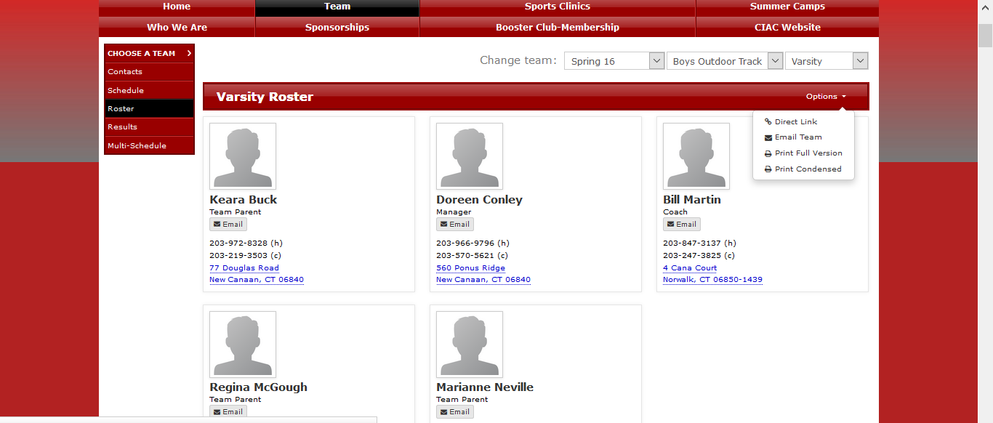

As a team parent, you have extra, administrative capabilities through League Athletics. You can email anyone at any level of the team (Freshman, JV, Varsity) and just parents or parents and players. To do so you must log in to your League Athletics Account. Select Admin at very top of screen, members and email members.

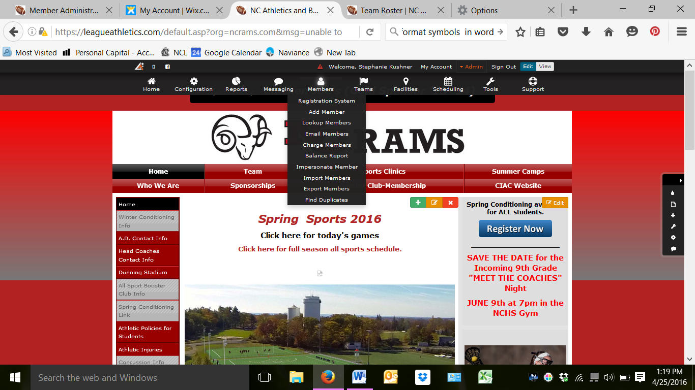

At that point you will be taken to the email interface. At this point, you can select who on your team you want to email (which team), do you want players, parents or both. To do so, first make sure the season you are looking for is correct. Then highlight the team you want to communicate with by clicking on it. If you want to send it to more than one team, you can hold down the ctrl button and click on whichever teams you want to email. Lastly, select the member type to determine if you want to email parents, players or all.
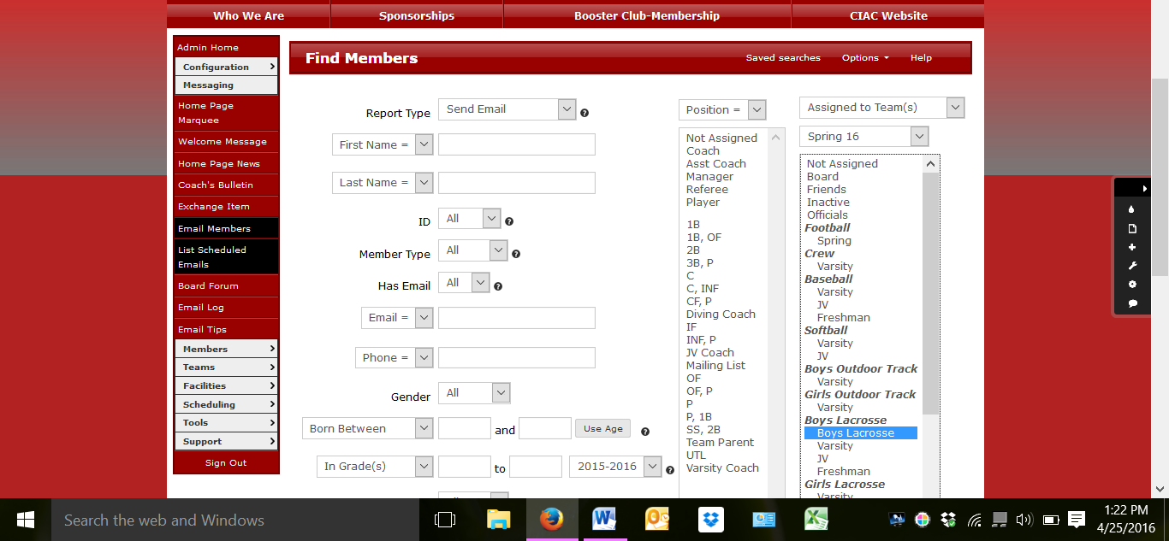

Scroll to the bottom of the page and select Find Members. You will then be taken to the area where you compose your email. Enter the name and email address you want it to come from and type your message in the Message Box. You will see how many emails will receive your message. Once you have finished your message you can send it right away or schedule it to be sent at a different time.

It is the Captains’ parents responsibility to ensure that your team manager (if you have one), is rostered on the team as a manager. Please contact the athletic office at nchsathletics@ncps-k12.org to ensure he or she is rostered if you do not see them listed on the team roster.

Team Page
When you log in you will see information about all of the administrative capabilities that you have. While some teams have full websites dedicated to their team, most rely on the information on the ncrams.com site. Typically the Athletics department will upload a link to your team calendar on the CIAC website. Do NOT PASTE A PICTURE OF YOUR CALENDAR ON YOUR PAGE. The calendar can and does change often so please be sure to use a live link. Many teams also choose to upload and store photos on the page and create sections with team news for important preseason or upcoming news.

